**Software Process Selection, Project Plan and Risk Management**

**P-10:Odysseum**

|  |  |
| --- | --- |
| **Student ID** | **Name** |
| **25100283** | **Muhammad Affan naved** |
| **25100225** | **Mohammad Haroon Khawaja** |
| **25100212** | **Shahrez Aezad** |
| **25100097** | **Pir M. Shahraiz Chishty** |
| **25100023** | **Luqman Aadil** |

|  |  |  |
| --- | --- | --- |
| **Content** | **Totals** | **Obtained** |
| Software Process Selection | 20 | 20 |
| Project context analysis | 10 | 5 |
| Gantt chart | 20 | 20 |
| Development environment preparation | 10 | 10 |
| Deployment platform | 10 | 10 |
| Risk Management | 15 | 15 |
| Who did what | 3 | 3 |
| Review checklist | 2 | 2 |
| Overall formatting/template | 5 | 5 |
| GitHub folder structure penalty | -15 | - |
| Late submission penalty | -20 | -20 |
| **Grand Total** | **100** | **65** |
| **General Comments/Individual Grading:** | | |

**Table of Contents**

1. Introduction 3

**2. Software Process Selection 4**

**3. Gantt Chart 6**

4. Development Environment Preparation 7

5. Deployment Platform 7

6. Risk Management 8

1.1 Potential Risks and Mitigation Strategies 8

Who Did What? 9

Review checklist 9

# Introduction

This project aims to develop a travel/social network application to help travelers plan their next trip using just one app. Rather than relying on blogs and pages from different online outlets, the app would be a one-stop solution for all travelers. The application will provide users a platform to search for various tourist destinations they may be interested in visiting and what these destinations have to offer such as accommodation, sightseeing, dining, nightlife, historical sites, and tour guides. Combining all these services onto one platform would improve the travel experience and will allow users to make well informed decisions based on information on the destinations..

Nowadays, travelers face a fundamental problem: finding accurate and relevant information. They have to rely on large commercial travel agencies that only have profit-driven goals or on personal connections that provide limited details and advice. This gives travelers an experience far from fulfilling, while local businesses gain limited benefits. The purpose of this app is to serve as a networking app to connect like-minded travelers and local service providers such that both parties benefit, with travelers having a fulfilling experience visiting their destinations and the local business being given an opportunity to boost the economic growth in the region.

As stated above, potential users of this app include travelers themselves, administrators and local businesses which are but not limited to hotels, restaurants and tour guides.

# Software Process Selection

1. **Waterfall**
   1. Pros
      1. Clear Structure: Each phase in development has well defined deliverables to be met by a given deadline.
      2. Thorough Documentation: Each phase requires the documentation of all deliverables to be well defined and comprehensive before going to the next phase.
      3. For projects that have well defined requirements and are not subject to major changes in the functionality, this process is ideal.
   2. Cons
      1. Late Feedback: Users usually only see the final project after the development is entirely completed which can create problems in case the developed software does not meet expectations.
      2. Inflexibility to Change: If a requirement has been changed by the client it can be difficult and costly if the project has moved on to later phases.
      3. Delays: In case of any delays during development, this can lead to a delay in delivery and can also be outdated upon delivery or release.
2. **Agile (Scrum)**
   1. Pros
      1. Flexibility: Changes in requirements or needs of the client can be incorporated into the project at any stage.
      2. Continuous Feedback: Users or clients are involved during all stages of development and their feedback ensures the product meets required standards.
      3. Faster Delivery: With the aid of sprints, the development team is able to deliver main components of the product quickly to the clients.
   2. Cons
      1. Inadequate Documentation: Since the main goal of this process is to produce a proper working software as fast as possible, documentation can get left behind, which can cause issues in the future in case of changes or if a new member joins the team.
      2. Predictability: Harder to predict exact deadlines and costs of development due to constant changes in product requirements.
3. **Chosen Strategy - Agile Scrum**
   1. **Justification**

We have chosen to use the Agile (Scrum) process for the following reasons.

* Since our project is a social media app for travellers and tourists, user feedback is critical for development in order for us to make necessary changes to improve user experience or add new features. Agile will allow us to keep these clients in the development cycle.
* Secondly, the sprint based approach of agile process allows us to provide primary features of the app faster to the user so that we can get their feedback in order to improve those features.
* Furthermore, we believe it is easier to identify any logical or integration issues during development and they can be addressed on the go in each sprint.
* Agile also provides flexibility for evolving requirements, so in the case of new requirements or changes in existing ones to keep up with current trends, they can be easily implemented during development.

# 3. Gantt Chart

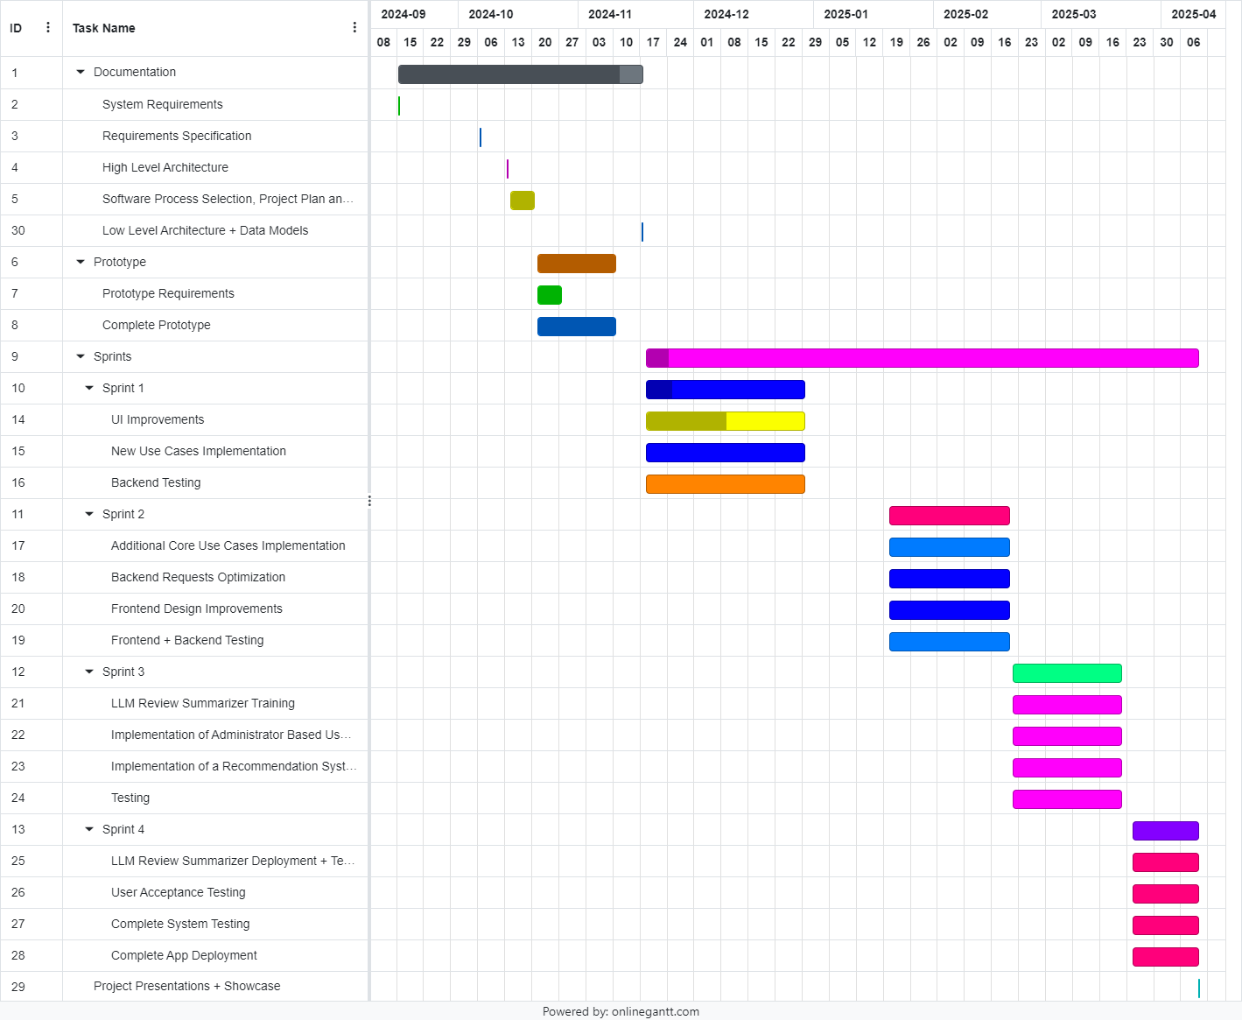

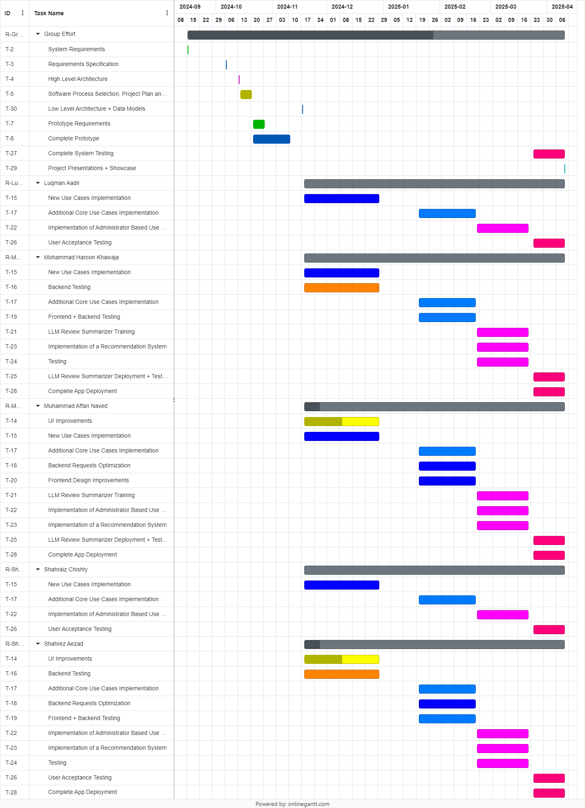

# Development Environment Preparation

1. **Tools**

The following tools are used throughout the entire development phase.

* The frontend will be built using React Native Expo using **SDK version 51**.
* The backend will be built using Node JS along with the **Express** library for routing. **Multer**, a library to handle file uploads, will also be used.
* We will be making use of 2 different database solutions for our app:
  + **MongoDB:** MongoDB will be used to store all user and app data including user credentials, post data and location reviews.
  + **Firebase:** Firebase will be used to store images and videos that a user uploads on their account.
* Git and Github will be used to manage the code among team members.

1. **Snapshots**
   1. Github Repo

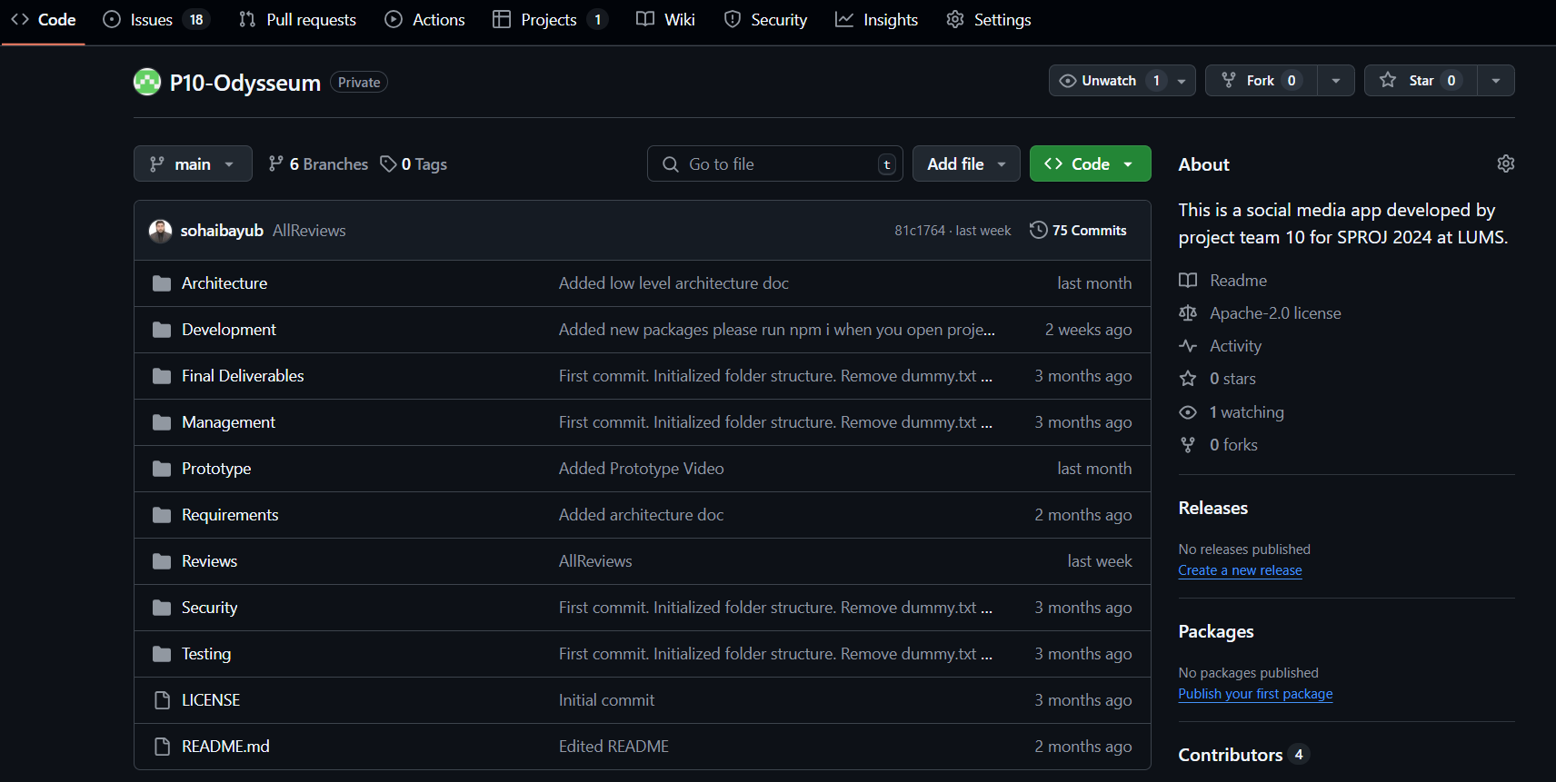

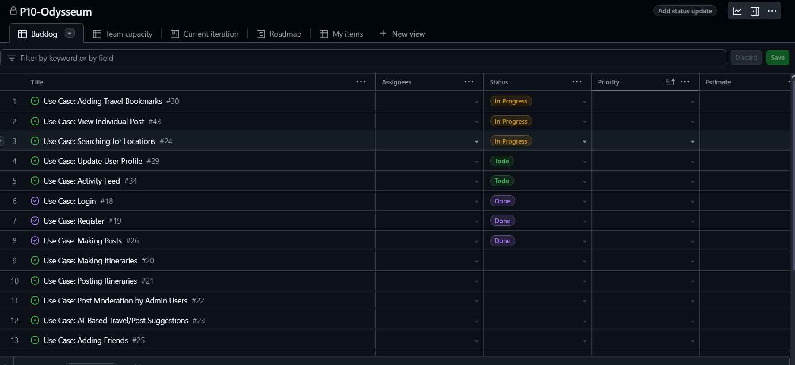

* 1. Project VS Code Structure

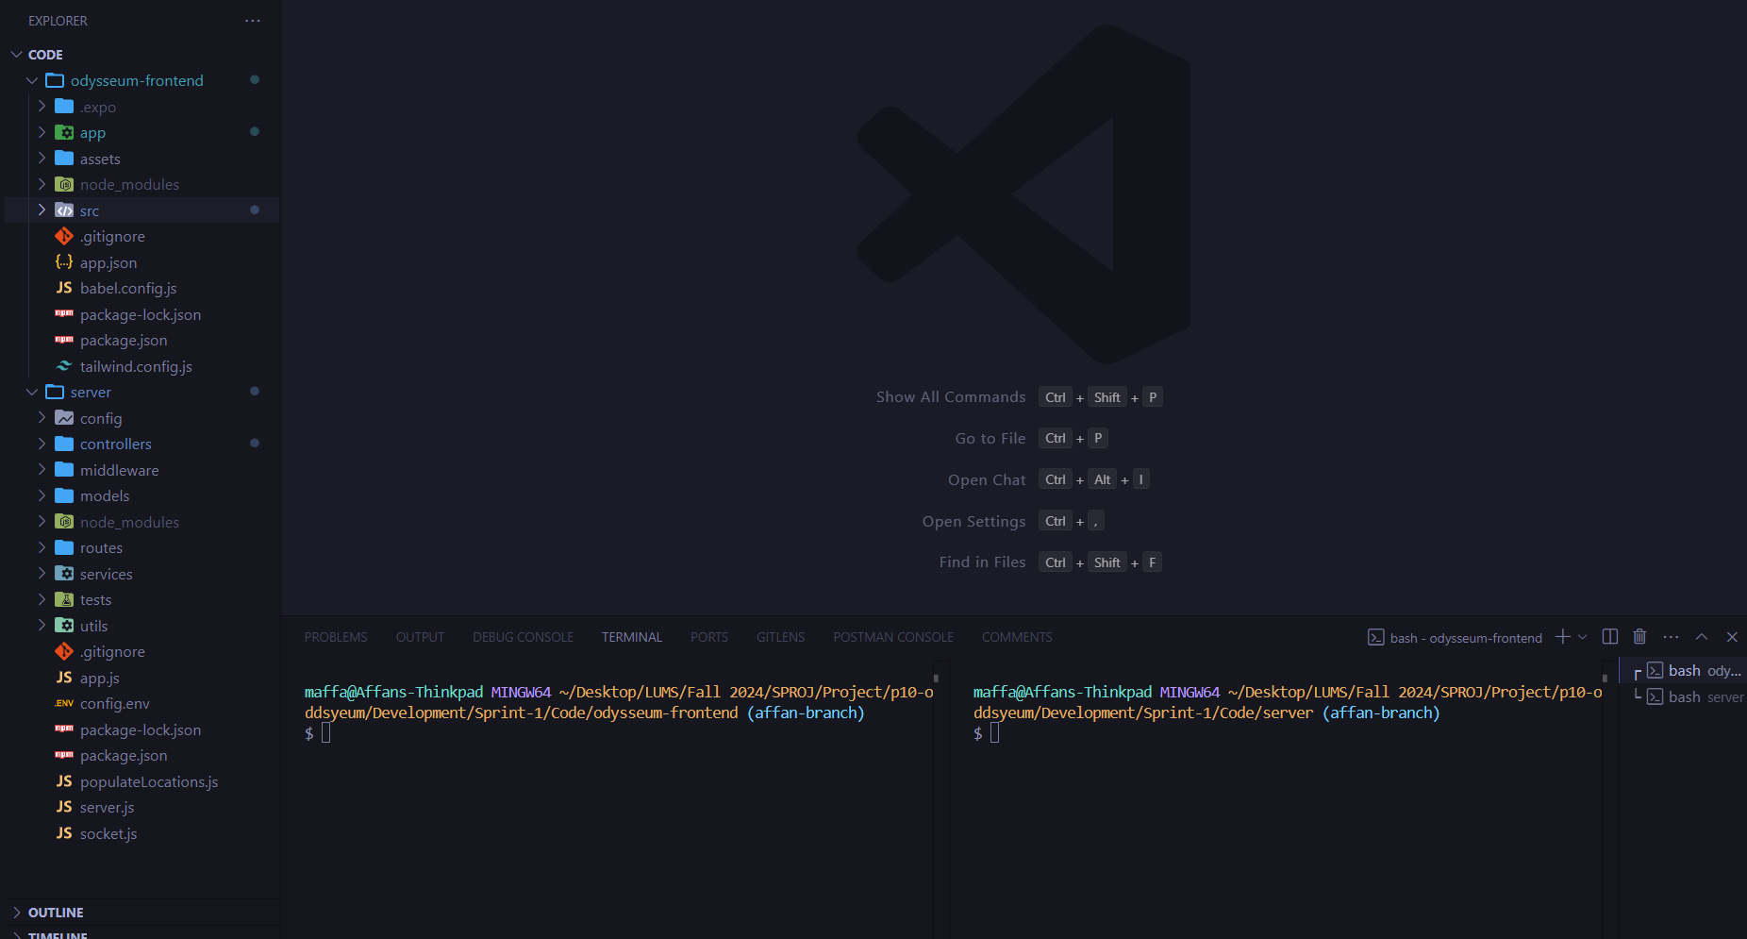

* 1. MongoDB

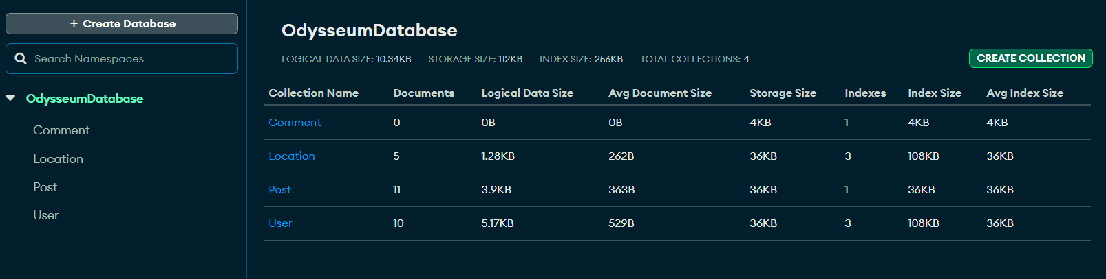

* 1. Firebase

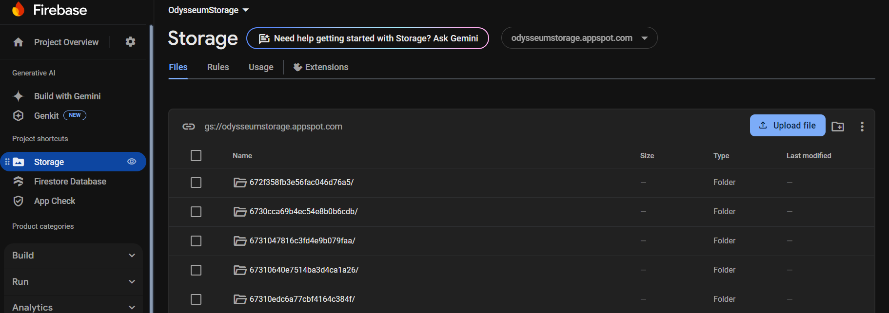

# 5. Deployment Platform

For deployment we have chosen to [**Render**](https://render.com) to deploy our backend server, since our backend is the only component which needs to be deployed. Render provides a free tier for backend hosting which provides sufficient resources for our prototype. Our frontend is going to be distributed as an APK file to users.

# 6. Risk Management

## Potential Risks and Mitigation Strategies

|  |  |  |
| --- | --- | --- |
| **Sr.** | **Risk Description** | **Mitigation Strategy** |
|  | Compromise of user data, loss of trust, legal implications. | Implement role-based access control to only allow admins to modify data. |
|  | Use of Unauthorized Developer APIs which can allow users access to sensitive operations. | Implement token based authentication to prevent app users from accessing these APIs and regularly update API keys and monitor access logs for suspicious activities. |
|  | Backend failure or maintenance downtime. | Implement auto scaling with load balancing to provision more backend servers on the cloud. |
|  | Loss or corruption of data due to a disaster. | Use database replication and implement regular data backup routines, create a disaster recovery plan. |
|  | Inappropriate or Malicious User Content | Allow users to report content and implement content moderation using AI tools and manual reviews. |
|  | Poor User Retention Engagement due to loss in interest or a competitor entering the market. | Regularly analyze user behaviour to stay up to date on latest trends.  Introduce a rewards system to enhance engagement. |
|  | Cultural and Language Barriers for tourists. | Include multi -language support along with local language translation features. |
|  | User Safety Concerns in Locations | Provide safety tips, verified reviews for tourist locations and contacts for local authorities. |
|  | High cost of Deployed Backend | Make use of cost optimized cloud services and serverless services (e.g. ECS Fargate on AWS) |
|  | Issues with scalability as platform and number of users grow. | Make use of horizontal scaling on cloud to provision more servers to keep up with growing demand. |

# Who Did What?

|  |  |
| --- | --- |
| **Name of the Team Member** | **Tasks done** |
| Muhammad Affan Naved | 1,2,3 |
| Mohammad Haroon Khawaja | 4 |
| Shahrez Aezad | 6 |
| Luqman Aadil | 2,5 |
| Shahraiz Chishty | 3,4 |

# Review checklist

Before submission of this deliverable, the team must perform an internal review. Each team member will review one or more sections of the deliverable.

|  |  |
| --- | --- |
| **Section** **Title** | **Reviewer Name(s)** |
| Software Process Selection | Shahrez Aezad |
| Gantt Chart | Mohammad Haroon Khawaja |
| Development Environment  Preparation + Deployment | Shahrez Aezad, Muhammad Affan Naved |
| Risk Management | Luqman Aadil, Shahraiz Chishty |